21. Write a LEX specification file to take input C program from a .c file and count tthe number of characters, number of lines & number of words.

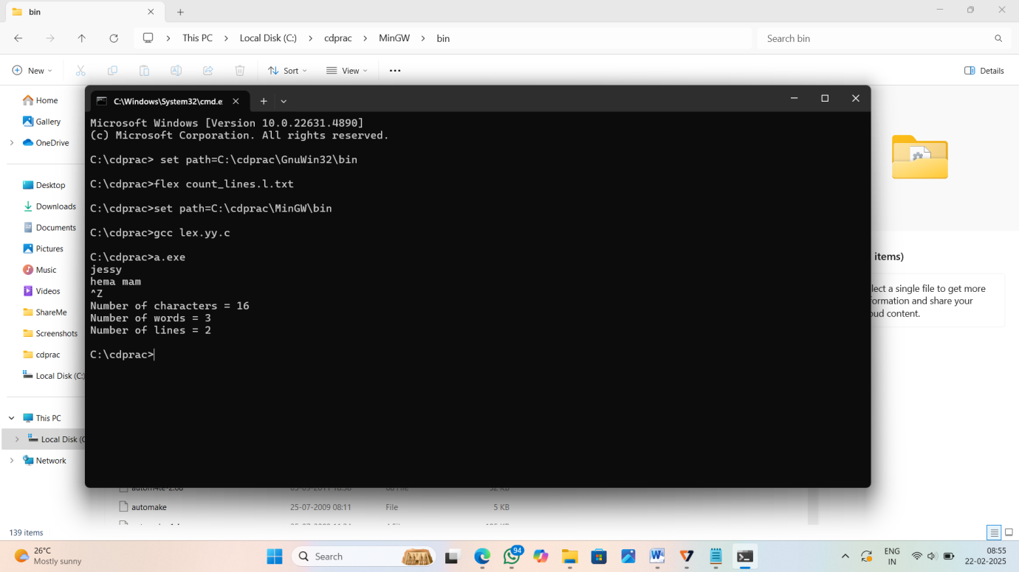

22.Write a LEX program to print all the constants in the given C source program file.

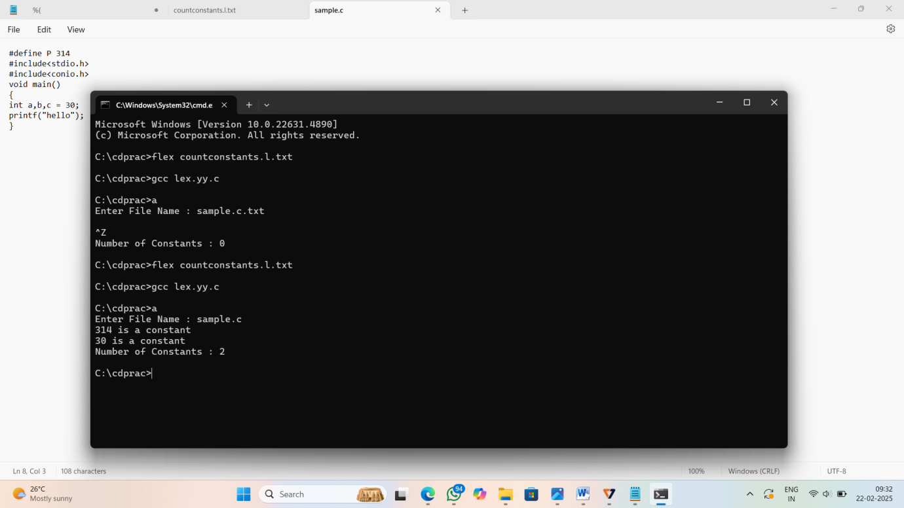

23.Write a LEX program to count the number of Macros defined and header files included in the C program.

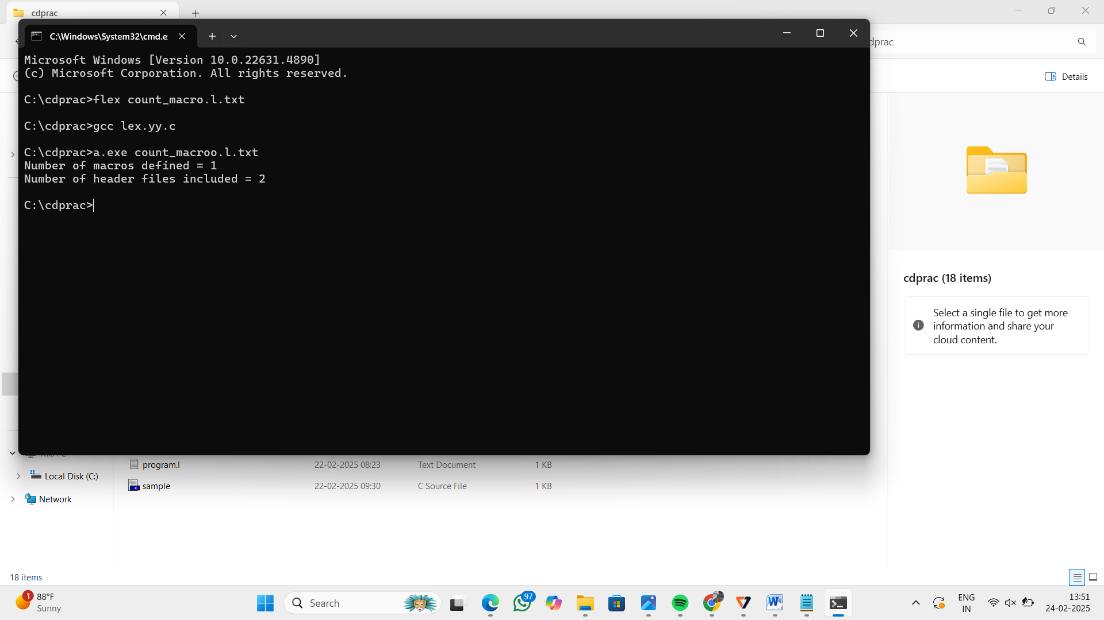

24. Write a LEX program to print all HTML tags in the input file.

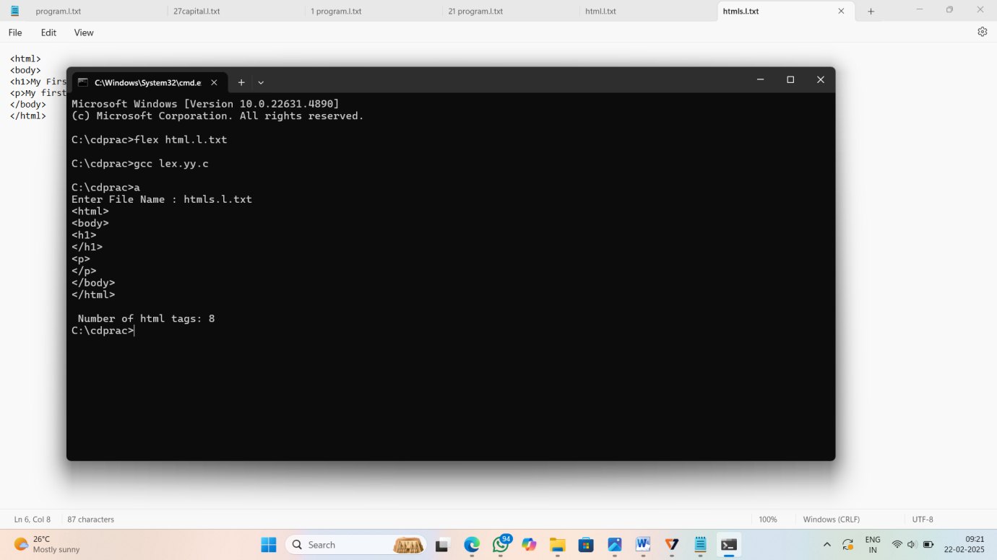

25. Write a LEX program which adds line numbers to the given C program file and display the same in the standard output.

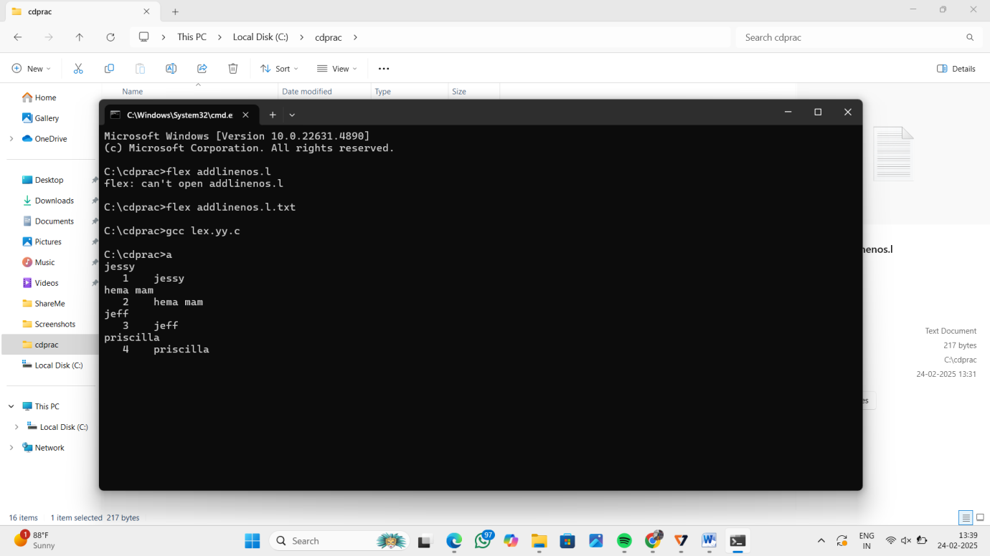

26.Write a LEX program to count the number of comment lines in a given C program and eiminate them and write into another file.

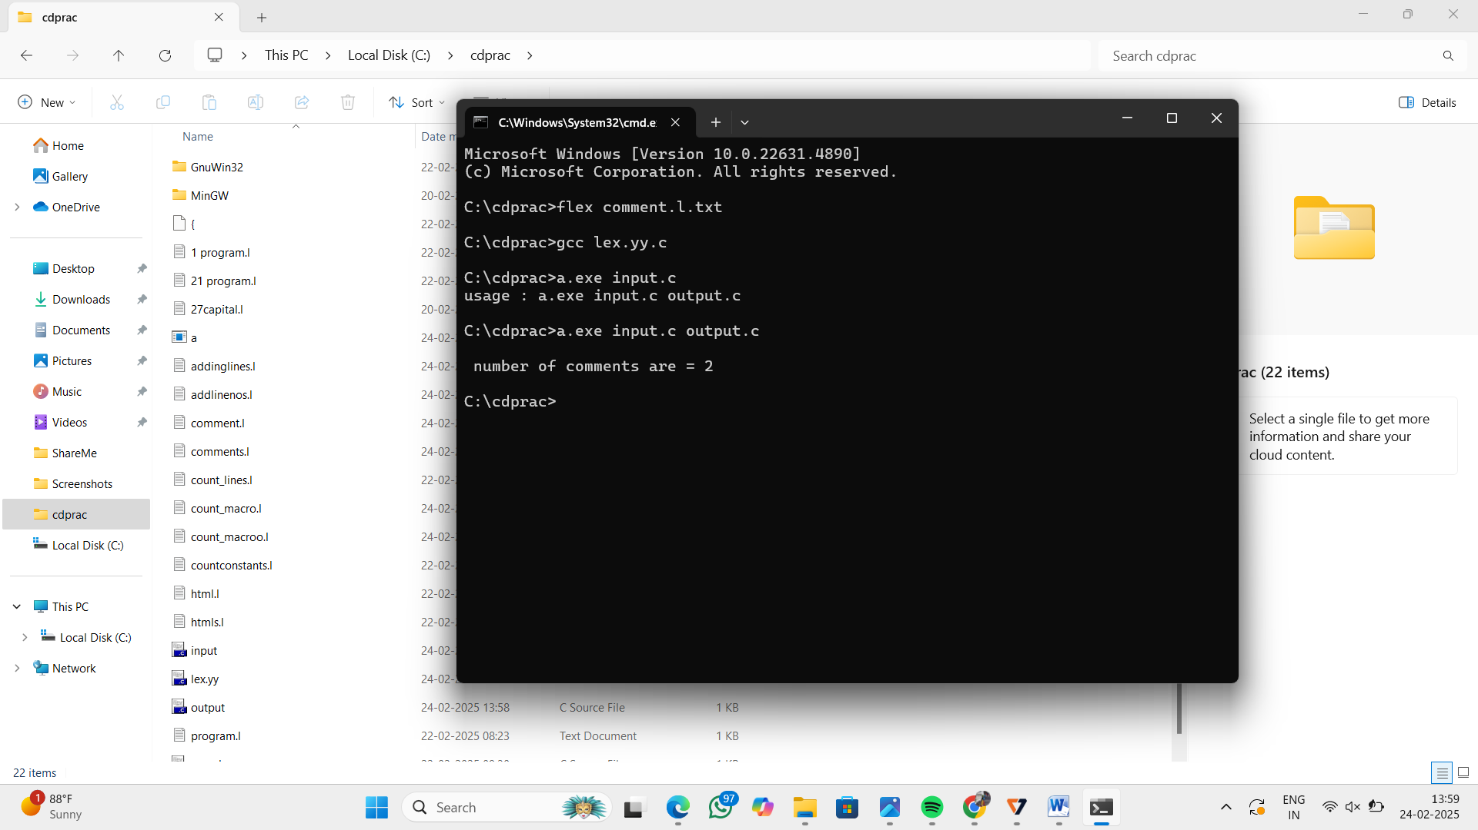

27.Write a LEX program to identify the capital words from the given input.

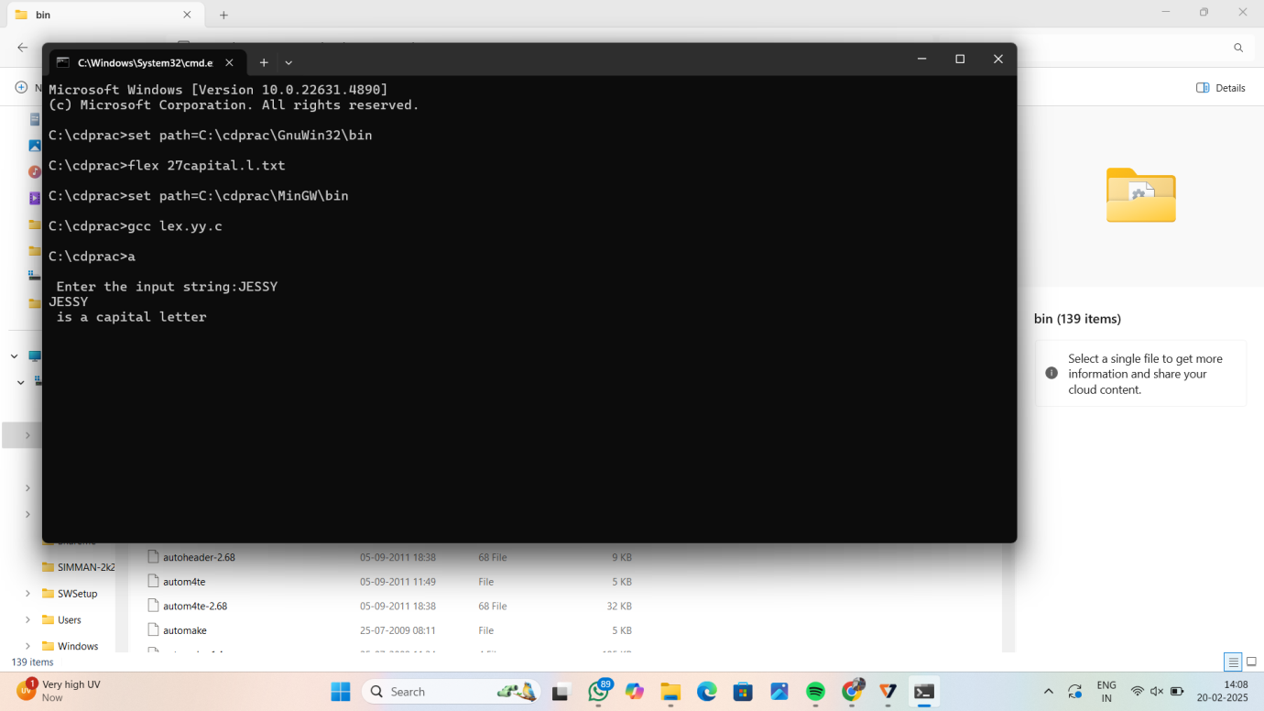

28. Write a LEX Program to check the email address is valid or not.

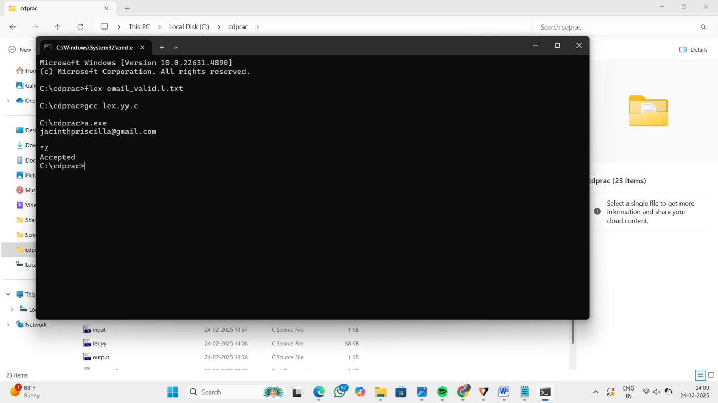

29. Write a LEX Program to convert the substring abc to ABC from the given input string

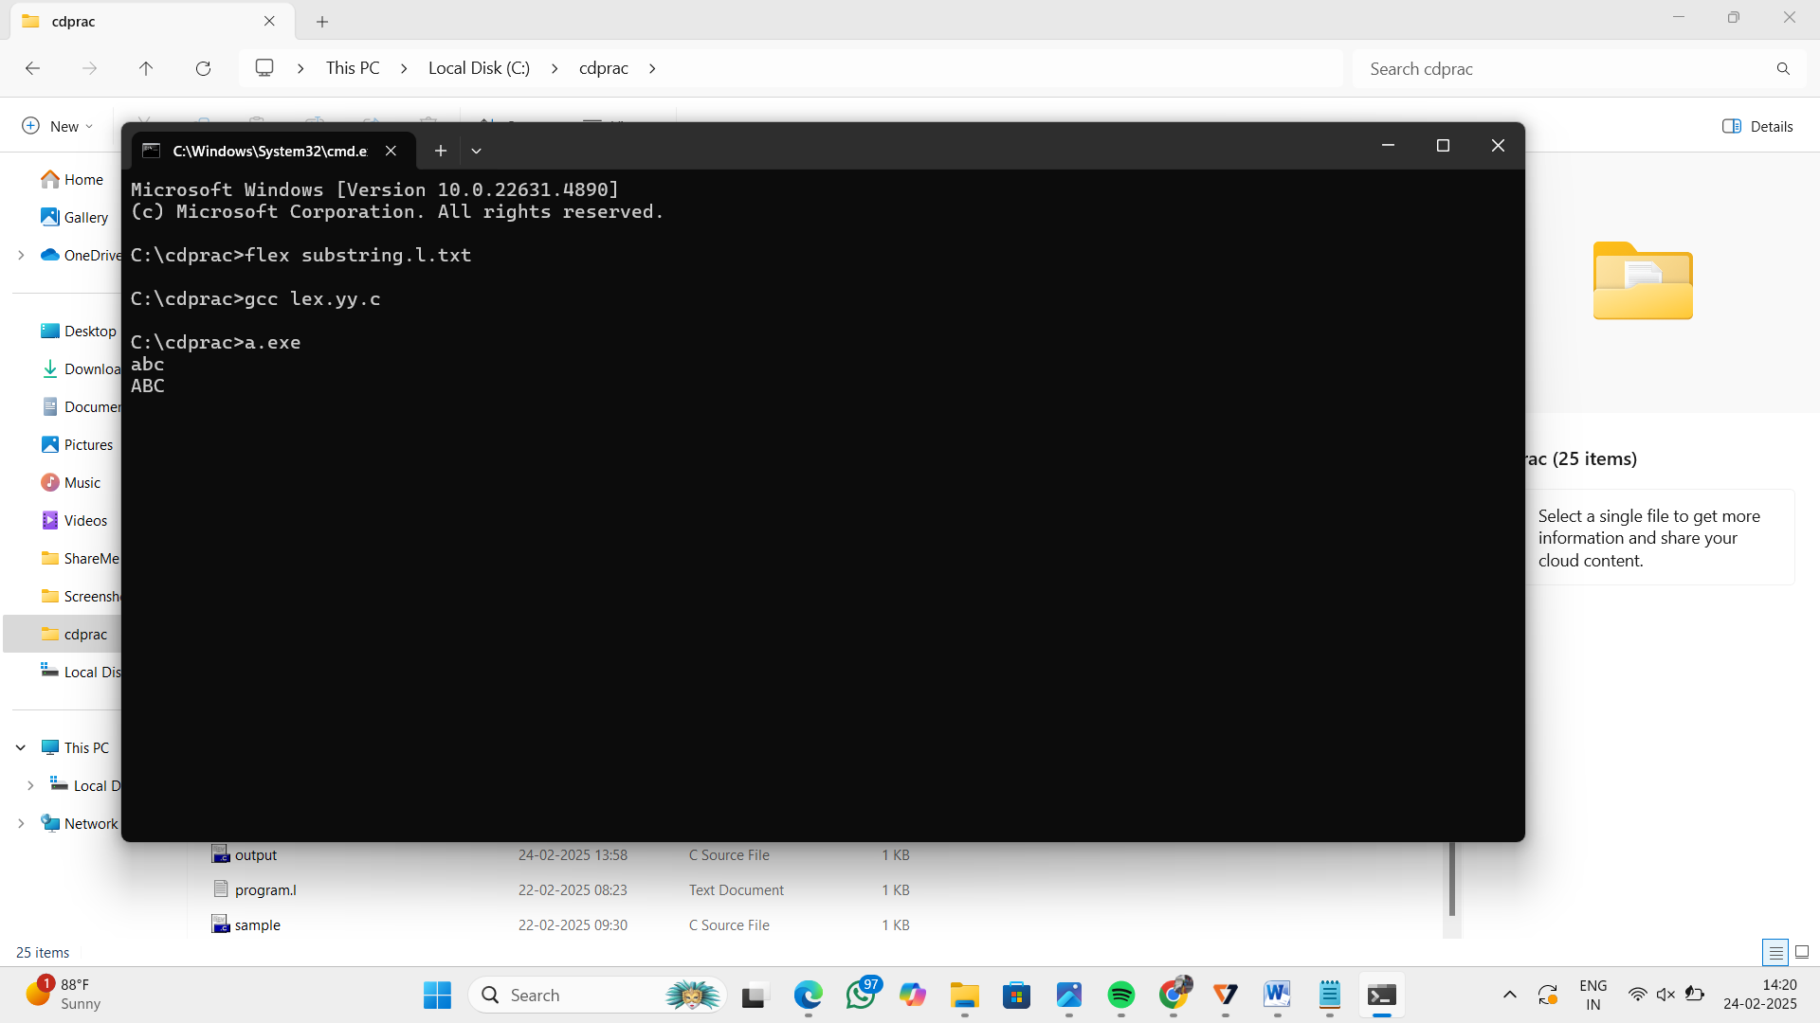

30. Implement a LEX program to check whether the mobile number is valid or not.

